- Purpose
  - The purpose of this document is to describe the procedure for assembling the Outer Electrical Panel on the Genesys Machine.
- Scope
  - This SOP applies to all equipment assembly team members. The process applies to the following machine ID’s:
EP50349EQS0600BE1200 – Outer Electrical Panel, G20 TR Disk
EP50350EQS0600BE1200 – Outer Electrical Panel, G20 TR ORB
EP50351EQS0600BE1200 – Outer Electrical Panel, G20 PA
EP50451EQS0600BE1200 – Outer Electrical Panel, G20 TR Disk, Lithium
EP50445EQS0600BE1200 – Outer Electrical Panel, G20 TR ORB, Lithium
- Responsibilities
  - The operations manager/supervisor is responsible for enforcing this SOP.
- Materials
  - The proper materials needed for this process are listed on the machine work order.
- Definitions

- Procedure
  - Start with an Outer Electrical Panel (E28990) and spray some soapy water onto it where the decal will go. Lightly spray soapy water on back of decal to ensure it can slide.

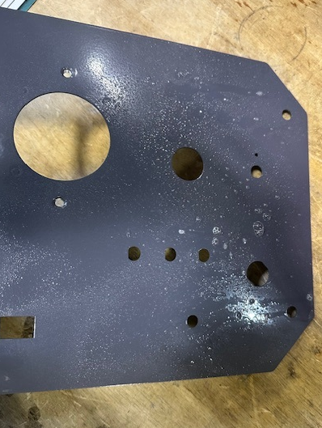

  - Stick a decal (E29007) into the appropriate location. It should be able to slide due to the water. Position it so that it is centered with all the holes and is square to the panel. Once positioned, use a squeegee to smooth the label and push out the water. Dry the panel off. There should be no bubbles or defects on the face.
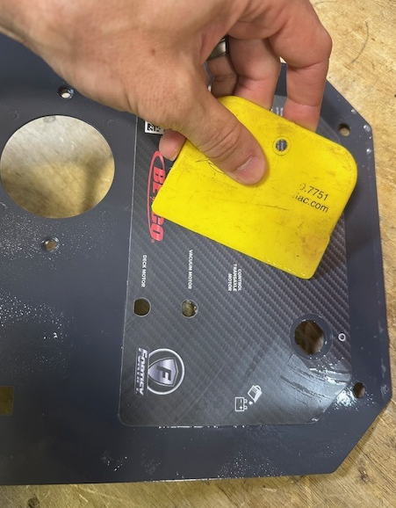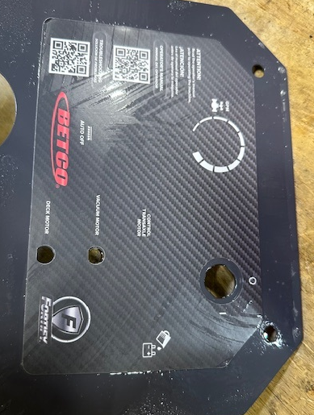
  - Attach a key switch (E12629) to the panel using the supplied nut. Ensure proper orientation of the component. The key should turn down to the lower portion of the circle. Verify that the key is tight and will not spin.
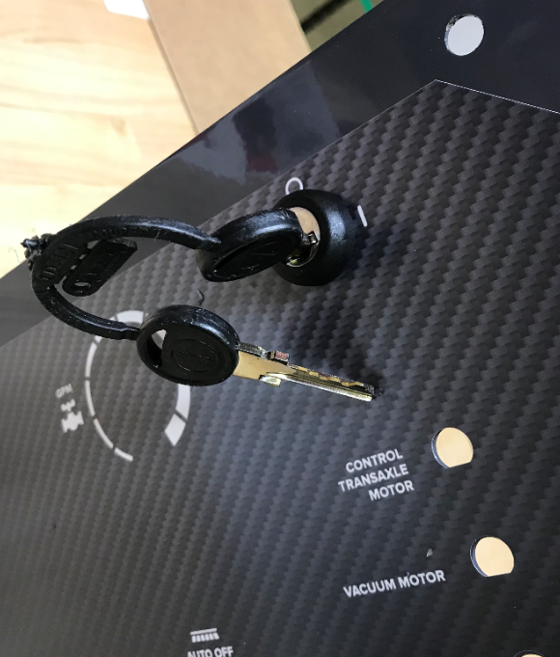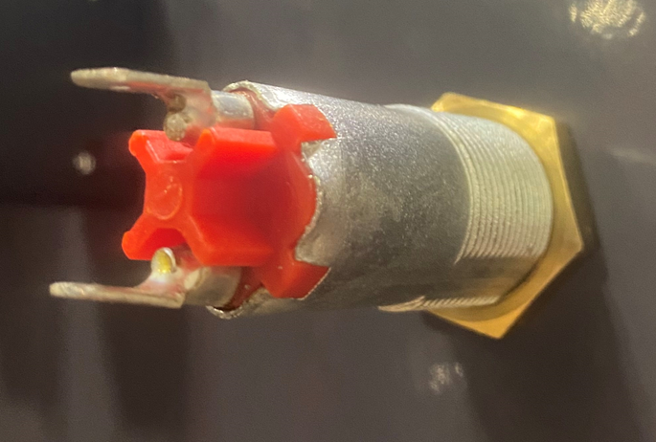

Correct “OFF” position
Correct “ON” position
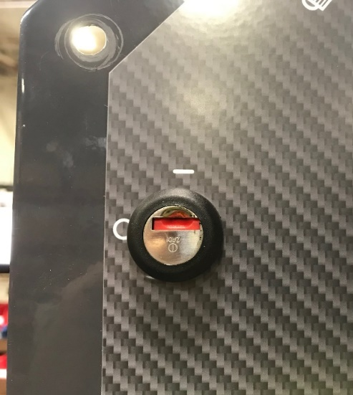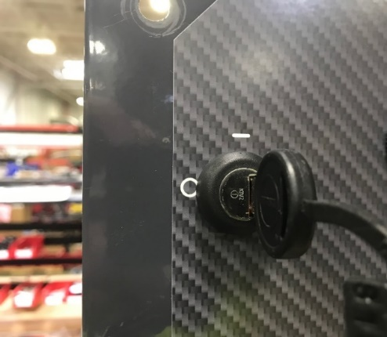
  - Cut out the decal on the panel where the solution potentiometer will mount. Place a spacer (E28768) over the nose of a solution potentiometer (E29706). The tab on the potentiometer will fit into the hole on the spacer. Use the supplied nut and washer to mount the potentiometer to the panel. The pin on the spacer will fit into the hole on the panel. Install a knob (E28606) onto the potentiometer using the supplied set screw. Put some blue Loctite on the set screw.

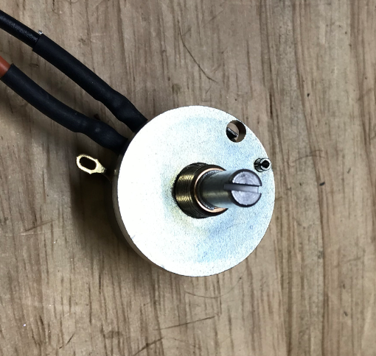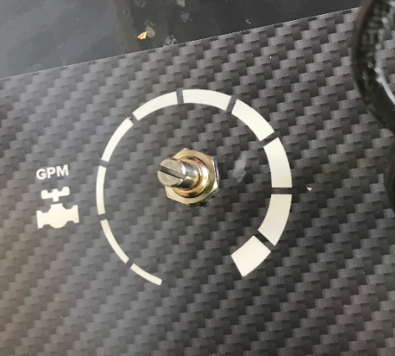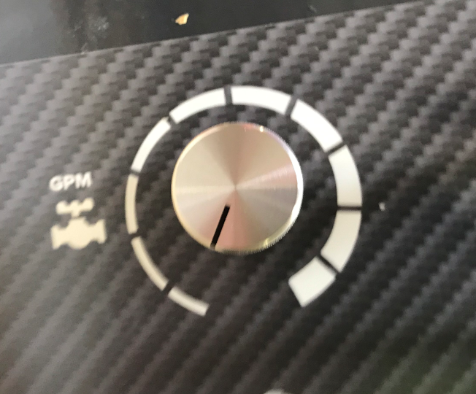
  - For a Disc Machine, cut out the decal where the pad on/off switch mounts, ensure prongs are facing down then install the button (E28967). NOTE: If an Orbital Machine is being built, skip this step.
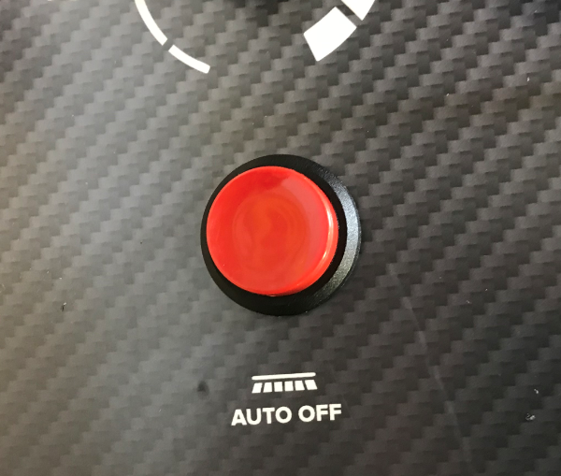
  - (Transaxle Machine Only) Cut out the 3rd circuit breaker hole on the decal (Control Transaxle Motor). Attach 3 circuit breakers (E28954) to the panel using the supplied nuts. Use an 11/16” socket to snug the thumb nuts to ensure they are tight. Do not overtighten as the label can wrinkle.

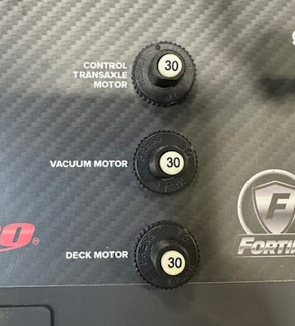

  - (Pad Assist Unit Only) Attach 2 circuit breakers (E28954) to the panel using the supplied nuts. These will be for the Vacuum Motor and the Deck Motor. Use an 11/16” socket to snug the thumb nuts to ensure they are tight. Do not overtighten as the label can wrinkle.

  - (With Solichem) Install the TDS Switch (E28781) into the panel in the appropriate orientation. Ensure the word “ON” points up. Stick a SoliChem ON/OFF decal (E29006) above the switch
(Without Solichem) Install Blank Switch (E28771) into the panel cutout.
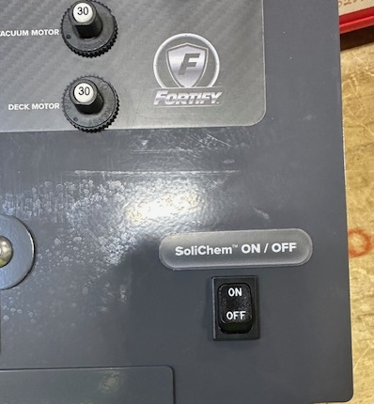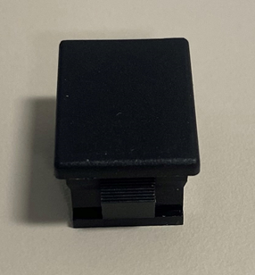
Blank
  - If the machine is to be equipped with a lithium battery, skip the next step. The machine will have an off board charger.
  - For a machine with Wet or AGM batteries, mount the charger (E28895) to the threaded studs on the panel using 4 flat washers (E29580) and 4 bolts (E28819).
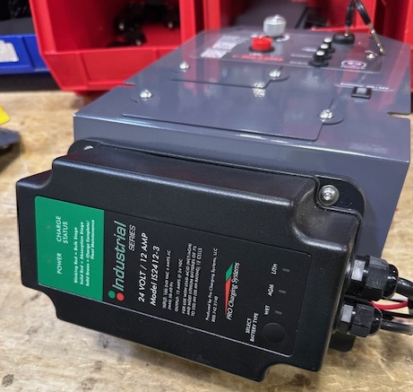
  - Install an armor cover plate (E29015) and timer cover plate (E29364) using 4 screws (E28648), 2 per cover plate.
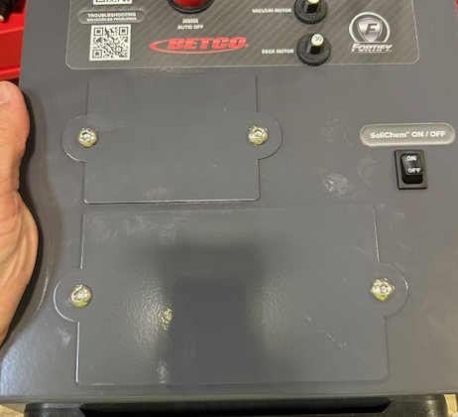

- References (optional section as needed)

- Training Guide

Functional Training Groups Requiring Training
Equipment Assembly Group

- SOP Change Control

Date of Change | Reason for Change
Rev 01 | This is the first version of the S.O.P. hence there are no revisions to this document.
Rev 02 – 1/19/2026 | Added step for lithium battery

Approvals

Submitter/Author Approval:__________________________________ Date:______________________

Management Approval:______________________________________ Date:______________________

QAU Approval:_____________________________________________ Date:______________________

